Week 10: LINEAR AND BINARY SEARCH
General Instructions:
1. Remove existing directories and create a fresh directory of your own. Write all the programs inside the newly created directory.
2. Remove the directory that you have created at the end of your Lab session.
3. Inform one of the TAs before you leave the Lab.
-------------------------------------------------------------------------------------------------------------------------------------
Given an array of elements, a linear search algorithm will scan all the elements in the array one-by-one from the first element till the last element and check if the element to be searched is present or not. A sample linear search program which scans the entire array.
In the above case of linear search, the elements in the array are allowed to be in any arbitrary order. Now, let us assume that the elements are in ascending order (it can also be in descending order). Under this assumption, the scanning of the element can be restricted till we find an element in the array which is equal to or greater than the element to be searched and modify the algorithm as follows.

Algorithm: LinearSearch
Input: An element e, a sorted array A
Output: Print the index of the element if FOUND
Assumption: A has n elements
BEGIN
- Initialize i = 0
- WHILE i < n
- IF A[i] $≤$ e THEN
- Break
- END IF
- i = i+1
- END WHILE
- IF i $<$ n THEN
- PRINT FOUND at i
- ELSE
- Print NOT FOUNT
- END IF
END

The above algorithm will its best case if the element is found at the first location, average case if the element is found at the arbitrary location, and worst case if the element is not found or found at the last location of the array.

Program/Source Code
Here is source code of the C Program to find the position of an element requested by the user using Linear Search Algorithm.
- /*
- * C program to input N numbers and store them in an array.
- * Do a linear search for a given key and report success or failure.
- */

- #include <stdio.h>

- void main()
- { int num;

- int i, keynum, found = 0;

- printf("Enter the number of elements ");
- scanf("%d", &num);
- int array[num];
- printf("Enter the elements one by one \n");
- for (i = 0; i < num; i++)
- {
- scanf("%d", &array[i]);
- }

- printf("Enter the element to be searched ");
- scanf("%d", &keynum);

- /* Linear search begins */
- for (i = 0; i < num ; i++)
- {
- if (keynum == array[i] )
- {
- found = 1;
- break;
- }
- }
- if (found == 1)
- printf("Element is present in the array at position %d",i+1);
- else
- printf("Element is not present in the array\n");
- }

Output:
Enter the number of elements 6
Enter the elements one by one
4
6
1
2
5
3
Enter the element to be searched 6
Element is present in the array at position 2
If we mandatorily assume that the elements are in sorted order, can we do better? Unlike linear search, instead of scanning the array from first to last, we can check the middle element directly. If the element to be searched is found in the middle, we stop searching. If the element to be searched is smaller than the middle element, then the element could be in the first half of the array. In such a case, we search only the elements in the first half and elements in the second half are ignored. If the element to be searched is larger than the middle element, then the element could be in the second half of the array. In such a case, we search only the elements in the second half and the elements in the second half are ignored. In this manner, the above search conditions are successively applied over the selected half of the intermediate array till the size of the array is 1 or element is found. This approach is called binary search. It is binary because larger array is divided into two smaller halves and search the element. Such an approach of dividing a bigger problem size into a smaller problem size(s) and solve the target problem is known as divide and conquer. Using divide and conquer, a complex problem may be able to solve more easily and efficiently and effectively. Recursive algorithms are generally divide and conquer. The above binary search approach is illustrated with the example below.

Input Array: A ={3, 5, 6, 10, 13, 17, 19, 20}, index start from 0
Element to be search: 4
Number of elements: n=8
Step 1: As array size is not 1, perform the following operations.
- Check the middle i.e., $A\left[\left\lceil \frac{8}{2}\right\rceil -1\right]=A[3]$ and compare with searched element i.e., 4
- The middle element i.e., 10 is not the searched element. Divide the array into two halves {3, 5, 6} 10 {13, 17, 19, 20}
- As middle element 10 larger than the searched element 4, select the first half i.e., {3, 5, 6}
Step 2: As array size is not 1, perform the following operations.
- Check the middle i.e., $A\left[\left\lceil \frac{3}{2}\right\rceil -1\right]=A[1]$ and compare with searched element i.e., 4
- The middle element i.e., 5 is not the searched element. Divide the array into two halves {3} 5 {6}
- As middle element 5 smaller than searched element 4, select the first half i.e., {3}, 5, 6}
Step 3: As the array size is 1, the element is not the search element, Print NOT FOUND and terminate.

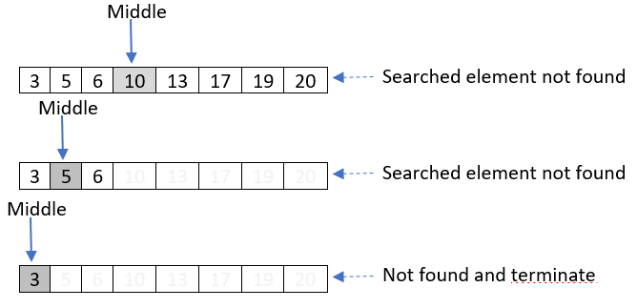

In the above scenario, comparisons with only three number of elements (out of 8 elements in the array) are performed. This three is nothing but $\left\lceil \log_{2}{8}\right\rceil =3$. Instead of 4, if we search 10, we can find in the first step itself, i.e., one comparison. Likewise, if we search 5, it needs two comparisons. For search element 3, it needs three comparisons.
If we search for 6, we get the element in three steps as shown in the following figure.
For 13, we get in three steps, For 17, we get in two steps as shown in the following figure.
For 19, we get in three steps.
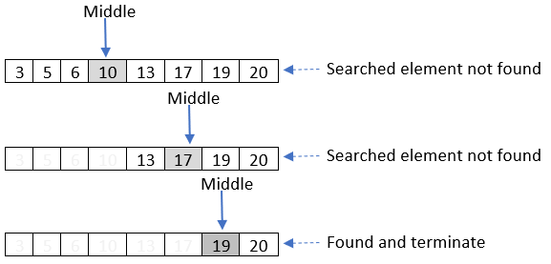
For 20, we get in four steps as shown below. Likewise, if we search any element larger than 20, it will take four steps.
An iterative binary search algorithm is given below. In every iteration of the while loop, the size of the array is reduced by half by updating the low or high variable by mid+1 or mid-1. Therefore, the while loop will iterate at the most upto $\log_{2}{n}$.

Algorithm: binarySearch
Input: ele-Element to be searched, A-array
Output: Return the index if found, -1 if not found
Assumption: Elements are in ascending order. There are n number of elements
BEGIN
- Initialization low=0, high=n-1, mid=-1
- WHILE low <= high REPEAT
- mid = CEILING((low + high)/2)
- IF A[mid]==ele THEN
- return mid
- ELSE IF ele > A[mid] THEN
- low = mid + 1
- ELSE THEN
- high = mid – 1
- END IF
- mid = -1
- END WHILE
END

Algorithm: binarySearch(A, ele, low, high)
Input: Array, Element to be searched, start index, end index
Output: Return the index if found, -1 if not found
Assumption: Elements are in ascending order.
BEGIN
- IF low > high THEN
- return -1
- ELSE
- mid = (low + high) / 2
- IF A[mid] == ele THEN
- return mid
- ELSE IF A[mid] < ele THEN
- return binarySearch(A, ele, mid + 1, high)
- ELSE THEN
- return binarySearch(A, ele, low, mid - 1)
- END IF
- END IF
END

Here is source code of the C Program to find the position of an element requested by the user using Binary Search Algorithm.
- /*
- * C program accept an array of N elements and a key to search.
- * If the search is successful, it displays "SUCCESSFUL SEARCH".
- * Otherwise, a message "UNSUCCESSFUL SEARCH" is displayed.
- */

- #include <stdio.h>
- void main()
- {
- int array[20];
- int i, low, mid, high, key, size;
- printf("Enter the size of an array\n");
- scanf("%d", &size);
- printf("Enter the array elements\n");
- for (i = 0; i < size; i++)
- {
- scanf("%d", &array[i]);
- }
- printf("Enter the key\n");
- scanf("%d", &key);
- /* search begins */
- low = 0;
- high = (size - 1);
- while (low <= high)
- {
- mid = (low + high) / 2;
- if (key == array[mid])
- {
- printf("SUCCESSFUL SEARCH\n");
- return;
- }
- if (key < array[mid])
- high = mid - 1;
- else
- low = mid + 1;
- }
- printf("UNSUCCESSFUL SEARCH\n");
- }
Runtime Test Cases
Enter the size of an array
4
Enter the array elements
90
560
300
390
Enter the key
90
SUCCESSFUL SEARCH

Bubble Sort
Given an array, bubble sort scans the array multiple times (referred to as pass) from the lower index to the highest applicable index. The idea is that, in each pass, depending on whether the algorithm attempts to arrange the data in ascending or descending order, the algorithm will bubble up the largest or smallest element. The algorithm can also scan the array from the largest index to the smallest applicable index, instead of smallest to higher. The process discussed in this section scans the array from the smallest to highest applicable index. We first illustrate the idea and procedure before presenting the algorithm/program.
Let A be the array to be sorted as shown below. Let the algorithm sorts the array in the descending order (from largest to the smallest).
We will scan the array from the smallest index to the highest applicable index. When the scanner moves forward, the smallest element among the elements processed so far will be kept bubbling up along with the scanner. In the pass 1, the idea is to bubble up the smallest element to the end of the array. When the scanner is at the index 0, the algorithm has processed the array up to index 0, in this pass. As the scanner has processed only one element i.e., $A[0]=8$, the smallest element is the element itself i.e., 8.
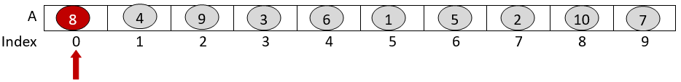
Then, the scanner moves to the second index, i.e., A[1] and compares the element at A[1] with the smallest element stored at A[0]. Since $A[1] <A[0]$, the elements are in order. No reordering is required. A[1] has the smallest element, as shown below.
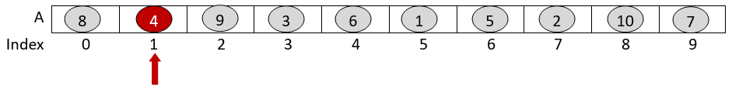
Now, the scanner moves to A[2] and compares with the smallest element found so far i.e., the previous element (A[1]). As $A[2]>A[1]$, the elements are not in order i.e., A[2] should have the smallest element. So, the elements at A[2] and A[1] are exchanged, as shown below. Now, A[2] has the smallest element.
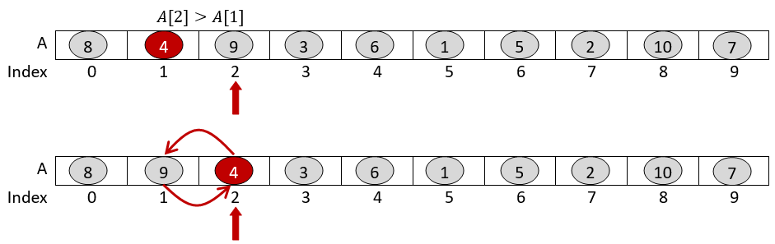
Likewise, scanning continues till the last element, as shown below.
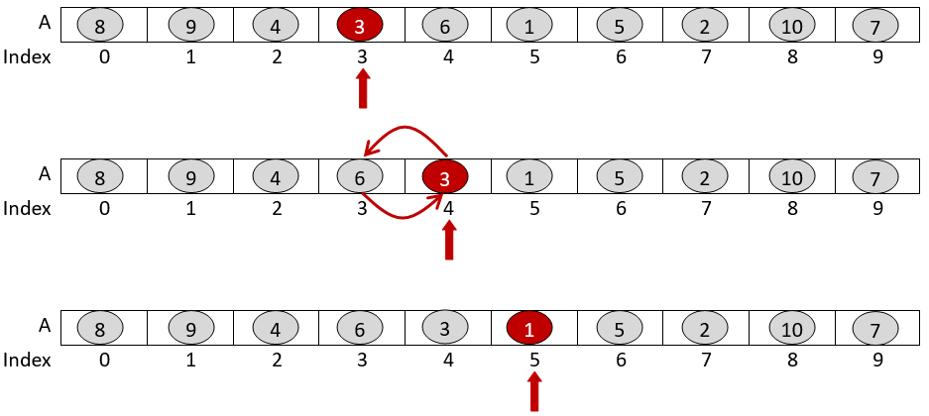

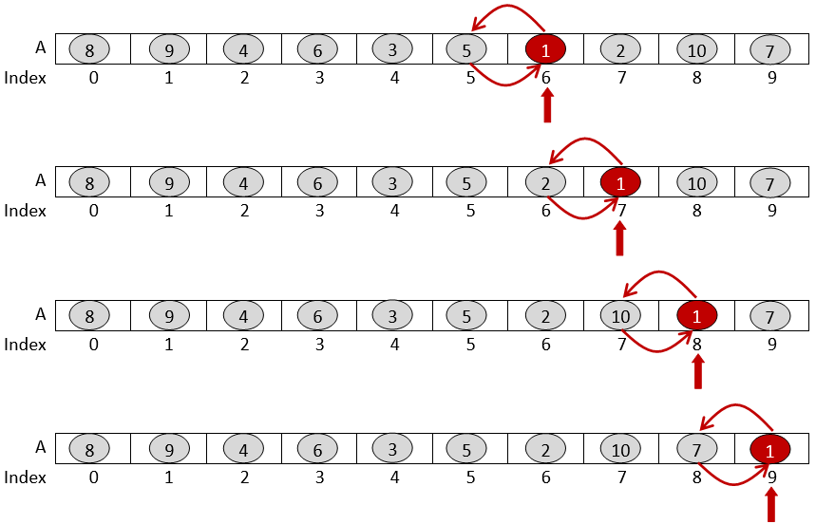
As illustrated above, when the scanner reaches the last index, the last index of the array has the smallest element. It can be noted that as the scanner moves forward, the smallest element is bubbled up along with the scanner. Hence, the algorithm is named as bubble sort. With this, the first pass is completed. In the second pass, the above scanning process is repeated from the smallest index to the second largest applicable index. As the smallest element in the array is found and stored at the last index i.e., A[9], the scanning will be done only upto second last index i.e., A[8].
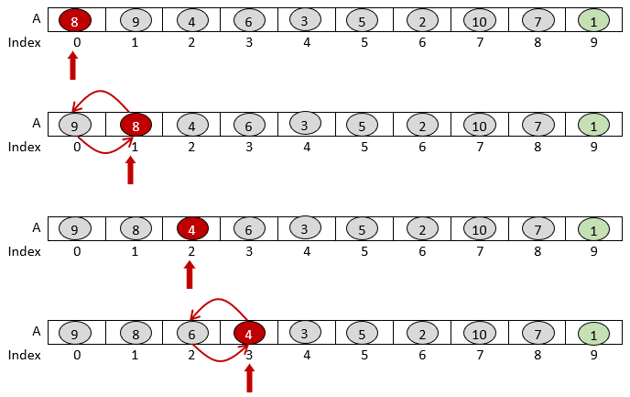

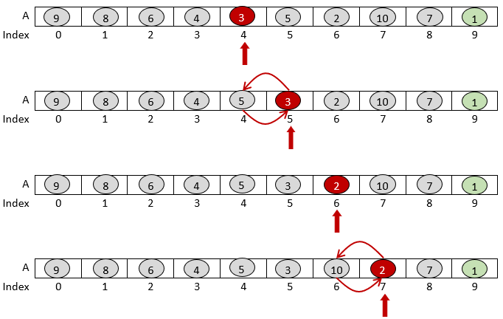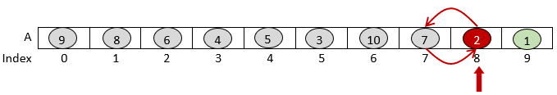
Likewise, the scanning continues for pass 2, 3, 4 and so on upto pass 10, and obtains the following pass-wise orderings.
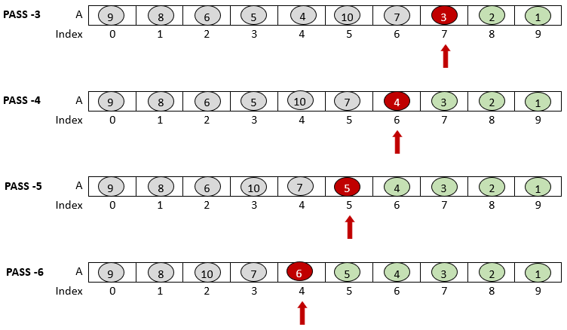

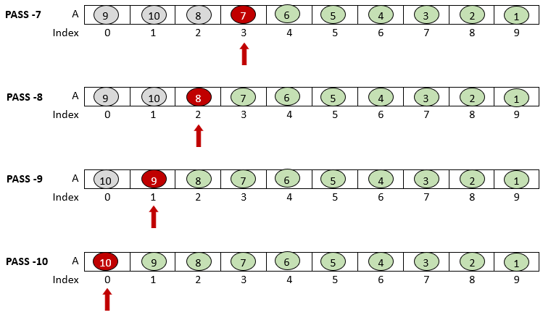
In the first pass, the algorithm performs $n-1$ number of comparisons. When the scanner is at the index 0, no comparison requires. It can simply move forward. As such, when the scanner is at index 0, we can start comparison with the second element, reducing the scanning in the first pass only upto $n-1$. In the second pass, the algorithm performs $n-2$ number of comparisons. Likewise, $n-3$ number of comparisons in 3rd pass, $n-4$ number of comparisons in 4th pass and so on. Though, there are 10 passes for 10 elements, the passes can stop at 9th pass, the element at index 0 will be in order by default at the end of the 9th pass. Therefore, there are $1+2+3+….+(n-2)+(n-1) =\frac{n(n-1)}{2}$ number of comparisons.
The algorithm is a comparable based algorithm as elements in the array are ordered by comparing between the values of the element and exchanging the unordered two elements. The algorithm is stable, in the event of having elements with same value, as the scanner can simply move forward without exchange. The algorithm is in-place algorithm as we do not use auxiliary data structure except for temporary variables for iterators, and possibly another variable for exchange operations. The algorithm is internal memory algorithm as it processes the elements in an array, and the entire array needs to be in RAM. An algorithm for bubble sort is given and briefly discussed in Unit 1. The following program shows an implementation of the above process.

void bubbleSort(int A[], int n){
int i, j, temp;
for (i = 0; i < n - 1; i++){
for (j = 0; j < n - i - 1; j++){
if (A[j] < A[j + 1]){
temp = A[j];
A[j] = A[j+1];
A[j+1] = temp;
}
}
}
}
In the above program, irrespective of the initial ordering of the elements in the array, every consecutive pairs are compared. The algorithm will perform $\frac{n(n-1)}{2}$ number of comparisons for all the input array. Therefore, the above program is not adaptive.
The above algorithm/program can be modified and made adaptive as follows. In the modified program given below, we incorporate a flag to check if the given input or intermediate array is in sorted order. Whenever there is an exchange of elements in any pass, the flag is set to true. If it finds a particular pass without any exchange, it means that the array is already in sorted order and the algorithm/program terminates. Hence, bubble sort algorithm can be modified to make it adaptive.
void bubbleSort(int A[], int n){
int i, j, temp, flag;
for (i = 0; i < n - 1; i++){
flag=0;
for (j = 0; j < n - i - 1; j++){
if (A[j] < A[j + 1]){
temp = A[j];
A[j] = A[j+1];
A[j+1] = temp;
flag=1;
}
}
if(flag==0) break;
}
}
The above program terminates if the inner loop does not set the flag. It means, the underlying array processed by the inner loop is already in the sorted order. With this modification, if the given input array is already in the sorted order (i.e., inversion count of the input array equals to 0), the algorithm will scan only one time and terminate.

Here is the source code of the C program to sort integers using Bubble Sort technique.
- /*
- * C Program to sort an array using Bubble Sort technique
- */

- #include <stdio.h>
- void bubblesort(int arr[], int size)
- {
- int i, j;
- for (i = 0; i < size; i++)
- {
- for (j = 0; j < size - i; j++)
- {
- if (arr[j] > arr[j+1])
- swap(&arr[j], &arr[j+1]);

- }
- }
- }
- void swap(int *a, int *b)
- {
- int temp;
- temp = *a;
- *a = *b;
- *b = temp;
- }
- int main()
- {
- int array[100], i, size;
- printf("How many numbers you want to sort: ");
- scanf("%d", &size);
- printf("\nEnter %d numbers : ", size);
- for (i = 0; i < size; i++)
- scanf("%d", &array[i]);
- bubblesort(array, size);
- printf("\nSorted array is ");

- for (i = 0; i < size; i++)
- printf(" %d ", array[i]);
- return 0;
- }
Runtime Test Cases
In this case, we are entering the numbers “345, 3, 20 35, 333” as input to sort them using bubble sort in ascending order.
$ gcc bubblesort.c -o bubblesort
$ ./bubblesort
How many numbers you want to sort: 5
Enter 5 numbers : 345 3 20 35 333
Sorted array is : 3 20 35 333 345

Insertion Sort
The idea in the insertion sort is to insert an element in a sorted subarray. Like in bubble sort, the insertion sort will also scan the array multiple times through different passes. However, unlike bubble sort, it assumes to have an intermediate sorted subarray, and a new element is inserted in order to the sorted sub-array in subsequent pass, as described below. Let us consider the following array and sort the array in ascending order.
In the first pass, we assume to have an empty sorted array, and the scanner inserts the element at index 0 to the empty sorted array. Thus, it produces a sorted subarray of element 8.
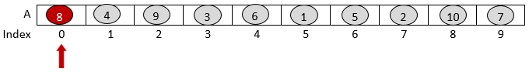
In the second pass, it considers the sorted subarray obtained from pass 1, and the scanner inserts the element at A[1] to the sorted subarray in order (ascending) by scanning backward, as shown below. As the element to be inserted 4 is smaller than the largest of the sorted subarray 8, 4 and 8 are exchanged.
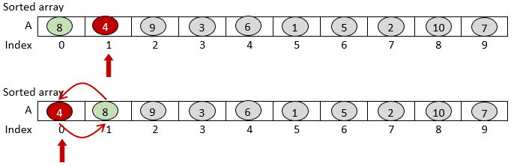
In the third pass, it considers the sorted subarray obtained from pass 2, and the scanner inserts the element at A[2] i.e., 9 to the sorted subarray (4, 8) in order (ascending) by scanning backward. However, 9 is larger than the largest element in the sorted sub array. Therefore, 9 is already placed in order, and terminate the pass.
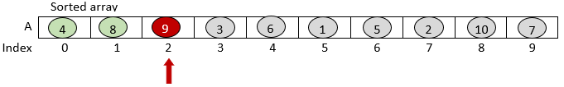
In the fourth pass, the scanner inserts the element at A[3] i.e., 3 to the sorted subarray (4, 8, 9) by scanning the array backward. 3 is smaller than 9, so 3 and 9 are swapped. Then, 3 and 8 are swapped. Lastly, 3 and 4 are swapped.
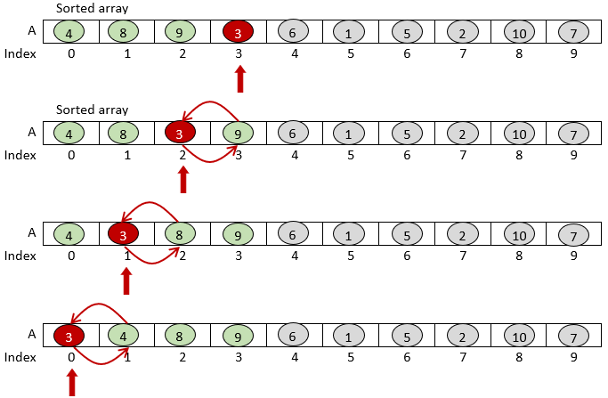
From the above passes, it can be seen that the first pass places the first element in order in the sorted subarray. The second pass places the second element, 3rd pass places the 3rd element, 4th pass places the 4th element in order in the corresponding sorted subarrays. In the similar manner, the remaining subsequent passes will place the corresponding element in the sorted subarray obtained from the previous pass, as shown below.
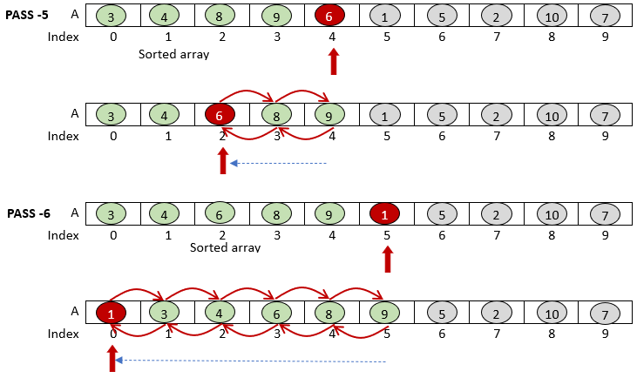
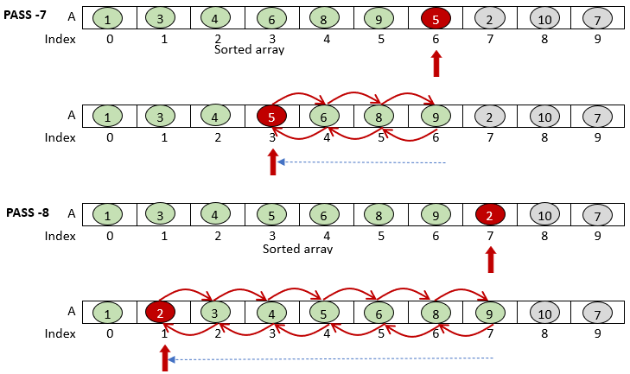
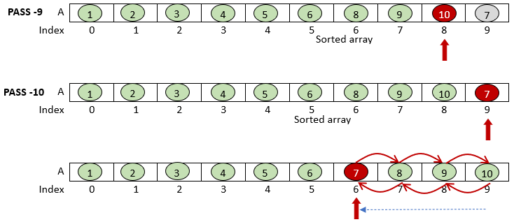
For the above example, it can be seen that in a particular pass, if the element to be inserted is larger than the largest element in the sorted subarray, that pass will perform only one comparison. Pass 3, 6 and 9 perform only one comparison as the target element is already in order. One comparison is required to check if the element is in order i.e., comparison with the largest element of the sorted subarray. As the number of comparisons required for sorting the array depends on the order of the elements in the array, insertion sort is adaptive. It can also be easily seen that the insertion algorithm is also stable and in-place. Since all the elements need to be in an array, it is also an internal algorithm.
void insertionSort(int A[], int n){
int i, j, ele;
for (i = 1; i < n; i++){
j = i - 1;
ele = A[i];
while ((j >= 0) && (A[j] > ele)){
A[j + 1] = A[j];
j = j - 1;
}
A[j + 1] = ele;
}
}
Like bubble sort, insertion sort is stable, in-place, internal memory, and comparable based sorting algorithm. Further, it is adaptive, as the running time depends on the initial ordering of the input array.

Here is source code of the C Program to sort an array of integers using Insertion Sort Algorithm.
- /* C Program to sort an array in ascending order using Insertion Sort */
- #include <stdio.h>
- int main(void)
- {
- int n, i, j, temp;
- int arr[64];
- printf("Enter number of elements\n");
- scanf("%d", &n);
- printf("Enter %d integers\n", n);
- for (i = 0; i < n; i++)
- {
- scanf("%d", &arr[i]);
- }
- for (i = 1; i < n; i++)
- {
- j = i;
- while (j > 0 && arr[j - 1] > arr[j])
- {
- temp = arr[j];
- arr[j] = arr[j - 1];
- arr[j - 1] = temp;
- j--;
- }
- }
- printf("Sorted list in ascending order:\n");
- for (i = 0; i < n; i++)
- {
- printf("%d\n", arr[i]);
- }
- return 0;
- }
Test Case :
Enter number of elements
5
Enter 5 integers
3 7 2 9 5
Sorted list in ascending order:
2
3
5
7
9

Selection Sort
In the above bubble sort and insertion sort algorithms, whenever two successive elements are out of order in the inner loop, they are exchanged. Can we reduce the number of swap operations while sorting an array? Selection sort is motivated by this question. Unlike bubble or insertion sort, selection sort does not swap the element immediately. Instead, a pass in the selection sort algorithm selects a location and scans the unordered array to find the element to be placed in the selected location. It, then, swaps the elements at the selected location and the location where the target element is found. For ascending order, the minimum element will be considered. However, for descending order, the maximum element will be considered. Let us say, we are sorting the array in ascending order, and in the $i^{th}$ pass, the $i^{th}$minimum element in the unsorted subarray is found at $loc$. Then, $A[i-1]$ and $A[loc]$ are swapped. We consider $A[i-1]$, because array index starts from 0, and pass numbering starts from 1, in our discussion below. Each pass performs at the most one swap operation.
Consider the following array and sort the elements in ascending order.
In the pass 1, scan the entire array and find the location of the smallest element $loc$. After finding the smallest element, swap the elements at $A[0]$ and $A[loc]$, as shown below. Each pass divides the array into two parts – sorted subarray and unsorted subarray.
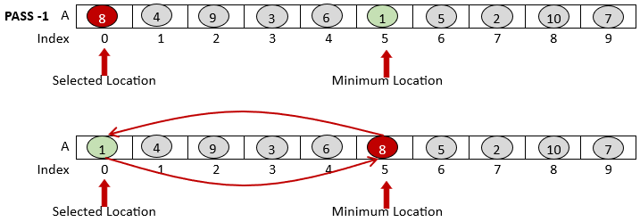
In the pass 2, scan the entire unsorted array and find the location of the smallest element $loc$. After finding the smallest element, swap the elements at $A[1]$ and $A[loc]$, as shown below. Pass 2 obtains the second element of the sorted subarray.
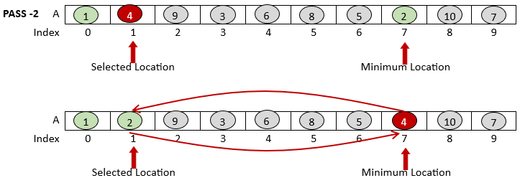

Like in pass 2, in pass 3, the scanner locates the location of the smallest element 3, and it is swapped with the element in the selected location, as shown below.
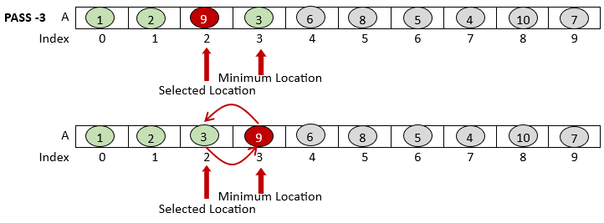
In the similar manner, in the subsequent passes, the minimum elements are located and placed in the corresponding selected locations, as shown below.
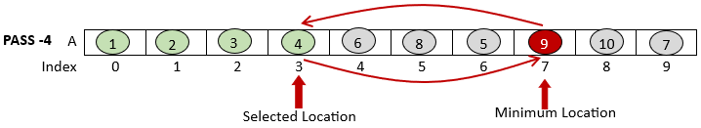
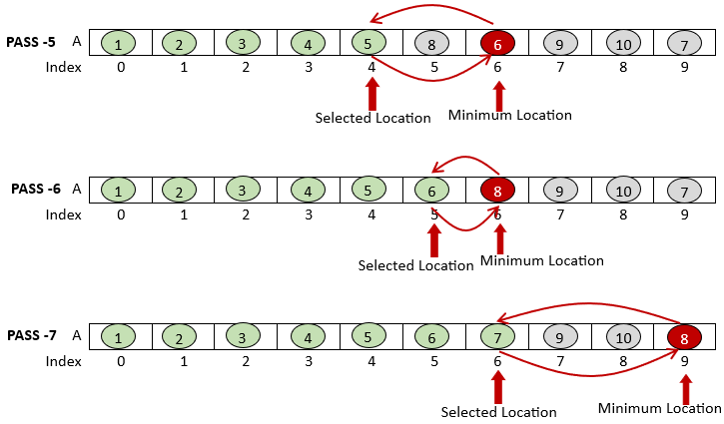
An implementation of the above process is given below. The outer loop acts as the pass and selects the location for which an appropriate minimum element should be found. The inner loop scans the unsorted subarray and finds the minimum element. The if-condition swaps the element in the selected location and the minimum. Like bubble and insertion sort, selection sort is stable, in-place, internal memory, comparable, but non-adaptive sorting algorithm.

void selectionSort(int A[], int n)
{
int i, j, min, temp;

for (i = 0; i < n-1; i++){ // selected location
min = i;
for (j = i+1; j < n; j++){ // find minimum location
if (A[j] < A[min])
min = j;
}
if(min != i){ // swap elements
temp = A[min];
A[min] = A[i];
A[i] = temp;
}
}
}

Here is source code of the C Program to sort an array of integers using Selection Sort Algorithm.
/*
* C Program to Implement Selection Sort
*/
#include <stdio.h>
void selectionSort(int arr[], int size);
void swap(int *a, int *b);
/*
* Selection sort function
*/
void selectionSort(int arr[], int size)
{
int i, j;
for (i = 0 ; i < size;i++)
{
for (j = i ; j < size; j++)
{
if (arr[i] > arr[j])
swap(&arr[i], &arr[j]);
}
}
}
/* Function to swap two variables */
void swap(int *a, int *b)
{
int temp;
temp = *a;
*a = *b;
*b = temp;
}
int main()
{
int array[10], i, size;
printf("How many numbers you want to sort: ");
scanf("%d", &size);
printf("\nEnter %d numbers\t", size);
printf("\n");
for (i = 0; i < size; i++)
scanf("%d", &array[i]);
selectionSort(array, size);
printf("\nSorted array is ");
for (i = 0; i < size;i++)
printf(" %d ", array[i]);
return 0;
}
Testcase : In this case, we are entering all unsorted elements, so the input array is {4, 6, 1, 2, 5, 3}.
How many numbers you want to sort: 6
Enter 6 numbers
4 6 1 2 5 3
Sorted array is 1 2 3 4 5 6

